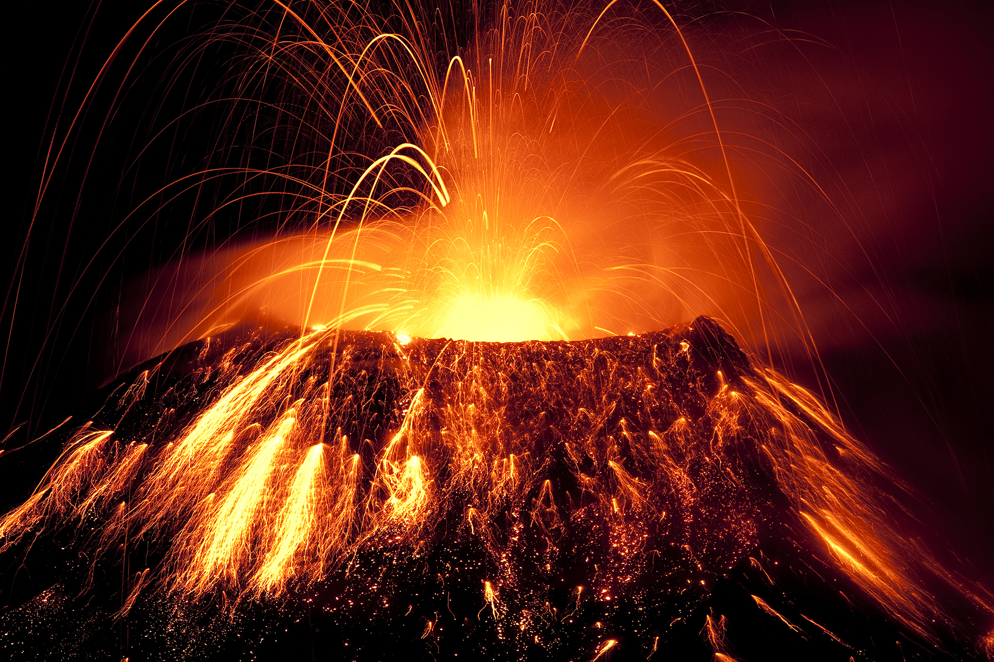
ENGLISH
Granny Came Here on the Empire Windrush- a contemporary story about the Empire Windrush and migration. Our main writing focus will be a factual report.
The Jabberwocky- a nonsense poem by Lewis Carrol about a hero who must help defeat the Jabberwocky. Our writing focus will be writing our own free verse poem.
FArTHER- is a moving picture book about a boy who inherits and ultimately fulfils his deceased father's lifelong, seemingly impossible, dream of flight. Our writing focus will be a narrative sequel.
Tar Beach- a book that tells the story of a young girl who lives in Harlem. It has themes of family and legacy. Our writing focus will be a play script.
Year 4 Topic Web- Spring
Volcanoes and Plate Tectonics
PE
In the first part of this term, the children will be learning about tennis. They will develop their skills in hitting and serving the ball. By the end of this unit the children will be able to rally and play short games.
In the second part of the term, the children will be learning about athletics and the different events involved in sports day; developing their throwing and jumping skills.

DT
In this unit the children will explore how to create a balanced meal using bread. We will explore the Eatwell plate and investigate which nutrients humans can get from which foods. We will also look at where certain foods come from. After this the children will design, create and evaluate their meal.

MUSIC
We will be learning how to play the glockenspiel. The children will learn about how musical notation functions in a song. The children will be practising keeping rhythm and learning a range of short tunes using the notes C, F, G, D and E. In the second half of the term, we will learn about gospel and soul music, focusing on the song Lean On Me by Bill Withers. We will also be preparing for our Easter production.
SCIENCE
Sound
We will explore how sounds are made by vibrations and how they travel through different materials to reach our ears. We’ll investigate how distance affects how loud a sound is, and how changes to an object can alter its pitch and volume. We will also test which materials are best at absorbing sound. Throughout the unit, we will carry out simple investigations to aid the children’s understanding.
Animals, including humans
In this unit we will look at the digestive systems of animals and humans. The children will explore the different parts and their functions. We will also look at a variety of different food chains from different habitats.

FRENCH
The children will be learning to recite a short poem from memory. Learning French nursery rhymes and how identify rhyming words in short texts. They will be learning how to say the French words for family members. We will explore how to say pet names in French and which pets are popular in France. The children will use these newly learned in context sentences and questions and will be encouraged to converse with each other to practise.

Geography
This term, the class will focus on plate tectonics and how the movement of the Earth’s crust shapes our world. They will learn about the Earth’s layers, the location and behaviour of tectonic plates, and how their movements create mountains, earthquakes, and volcanoes. Children will study real examples of these natural events, explore why some communities develop in high-risk areas, and learn how people protect themselves. They will also build their map and locational skills by identifying plate boundaries, earthquake-prone regions, and major volcanoes around the world.

ART
This term we will using a range of different mediums in art to create pieces of art inspired by local landscapes. The children will draw on their knowledge of perspective help them. The children will use a range of different textures to help convey movement and expression.

COMPUTING
The children will be creating websites using Google Sites. They will learn how to create different pages on the website, insert text boxes and images and publish the websites for their classmates to view.
RSHE
We will be covering the second unit from the TenTen programme, where we will be looking at ‘Created to Love by God’. In this unit the children will learn about friendships and families and what to do when they have disagreed with their friends. We will also look at how to stay safe online and how to look after our bodies.

RE
The spring term is always a very exciting time in RE. In this term we learn about the life Jesus led, his baptism, when he was transfigured and his presentation at the temple. We will also explore Jesus’ ancestors from the Old Testament King David, Jesse and Moses and how they lead the Jewish people. Later on in the term we will start to look at how Catholics use lent as a time of reflection and reconciliation, much like Jesus did when he went into the desert for 40 days and 40 nights. In this part of the term, we will also reflect on how other religions such as Islam and Judaism share similar times of fasting to Lent. Then at easter we will reflect on the events of holy week. We will explore the celebration of Jesus arriving to Jerusalem on Palm Sunday. We will examine the reasons Jesus was sentenced to death by Pontius Pilate.

MATHS
3, 6 and 9 times tables
The children will develop fluency in their recall of this times tables while developing a knowledge of the relationships between each of them. They will be able to deploy a range of strategies to help them calculate increasing complex multiplication problems.
7 times table
The children will develop fluency in their recall of this time stable recalling number facts from other tables to support them to do this.
Understanding multiplicative relationships
The children deepen their understanding of multiplication and division by exploring the distributive law. By the end of this unit the children will be able to apply this to multiplication calculations of greater value.
Coordinates
Children will be able to move coordinates on grid to new locations. They will be able to draw polygons on a grid and translate them to new positions.

